Mesh Topology

🕸️ What Is a Mesh Topology?
# Source: Chatgpt (GPT‑5 Mini) at [12/18/2025]
A mesh topology is a network layout where each device is connected to one or more other devices, creating a web-like structure. In a fully connected mesh, every node is directly connected to every other node.

What Is a Web-like Structure
# Source: Chatgpt (GPT‑5 Mini) at [12/18/2025]
A web-like structure in networking refers to a network topology where devices (nodes) are interconnected in multiple directions, forming a pattern that resembles a spider web.
This term is most often used to describe:
🔹 Mesh Topology — especially Full Mesh or Partial Mesh networks.

🧠 Simple Definition:
# Source: Chatgpt (GPT‑5 Mini) at [12/18/2025]
A web-like structure means devices are connected to many others, creating multiple paths for data to travel — like the threads of a web.

🖼️ Visual Representation:
# Source: Chatgpt (GPT‑5 Mini) at [12/18/2025]
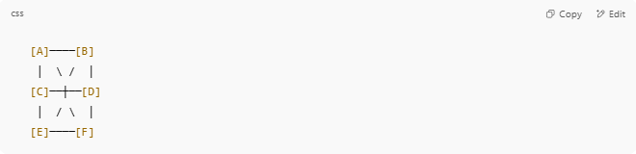
[A]────[B]
│ \ / │
[C]──┼──[D]
│ / \ │
[E]────[F]

Each node is connected to several others — not just one or two like in a star or ring topology.

📌 Why It Matters:
# Source: Chatgpt (GPT‑5 Mini) at [12/18/2025]
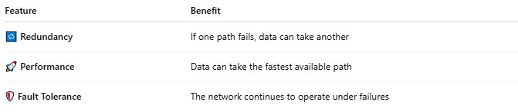
Feature | Benefit
🔁 Redundancy | If one path fails, data can take another
🚀 Performance | Data can take the fastest available path
🛡️ Fault Tolerance | The network continues to operate under failures

🛠 Examples of Web-like Structures:
# Source: Chatgpt (GPT‑5 Mini) at [12/18/2025]
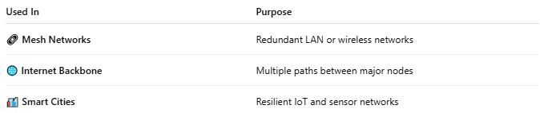
Used In | Purpose
🔗 Mesh Networks | Redundant LAN or wireless networks
🌐 Internet Backbone | Multiple paths between major nodes
🏙️ Smart Cities | Resilient IoT and sensor networks

✅ Summary
# Source: Chatgpt (GPT‑5 Mini) at [12/18/2025]

Term | Web-like Structure
Means | Devices are interconnected like a web
Seen In | Mesh topologies and redundant systems
Benefits | High availability, multiple paths

🧠 Simple Definition:
# Source: Chatgpt (GPT‑5 Mini) at [12/18/2025]
In a mesh topology, devices are interconnected to ensure multiple data paths exist between any two points, offering high redundancy and fault tolerance.

🔗 Types of Mesh Topology
# Source: Chatgpt (GPT‑5 Mini) at [12/18/2025]
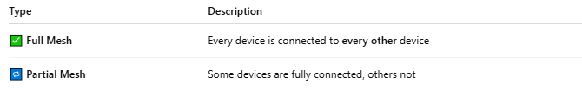

Type | Description
✅ Full Mesh | Every device is connected to every other device
🔁 Partial Mesh | Some devices are fully connected, others not

🖼️ Visual Example

✔ Full Mesh:
# Source: Chatgpt (GPT‑5 Mini) at [12/18/2025]
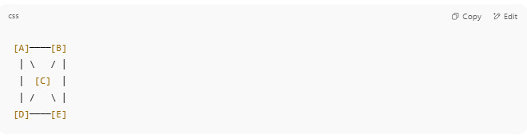

[A]────[B]
│ \ / │
│ [C] │
│ / \ │
[D]────[E]

➖ Partial Mesh:
# Source: Chatgpt (GPT‑5 Mini) at [12/18/2025]
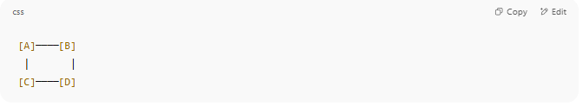
[A]────[B]
│ │
[C]────[D]

(only some devices are interconnected)

📦 How It Works
# Source: Chatgpt (GPT‑5 Mini) at [12/18/2025]
- Data can take multiple paths to reach its destination.
- If one path fails, the network reroutes traffic using an alternative path.
- Mesh is common in wireless, data center, and mission-critical networks.

✅ Advantages
# Source: Chatgpt (GPT‑5 Mini) at [12/18/2025]
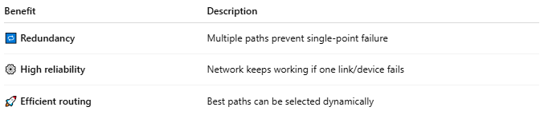

Benefit | Description
🔁 Redundancy | Multiple paths prevent single-point failure
⚙️ High reliability | Network keeps working if one link/device fails
🚀 Efficient routing | Best paths can be selected dynamically

❌ Disadvantages
# Source: Chatgpt (GPT‑5 Mini) at [12/18/2025]
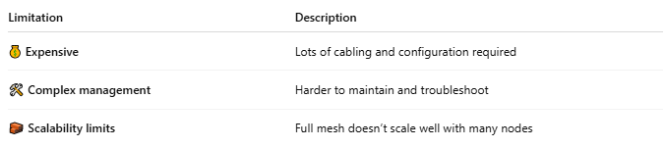

Limitation | Description
💰 Expensive | Lots of cabling and configuration required
🛠️ Complex management | Harder to maintain and troubleshoot
🧱 Scalability limits | Full mesh doesn’t scale well with many nodes

🛠️ Common Use Cases
# Source: Chatgpt (GPT‑5 Mini) at [12/18/2025]
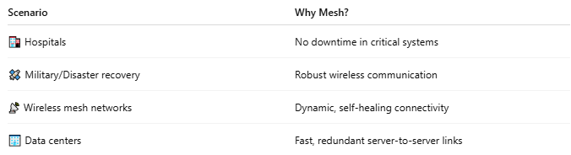

Scenario | Why Mesh?
🏥 Hospitals | No downtime in critical systems
🛰️ Military/Disaster recovery | Robust wireless communication
📡 Wireless mesh networks | Dynamic, self-healing connectivity
🏢 Data centers | Fast, redundant server-to-server links

📐 Formula: Full Mesh Connections
# Source: Chatgpt (GPT‑5 Mini) at [12/18/2025]
For N devices, full mesh requires:
N(N - 1) / 2 connections
📌 Example: 5 devices → 5(5-1)/2 = 10 connections

✅ Summary
# Source: Chatgpt (GPT‑5 Mini) at [12/18/2025]
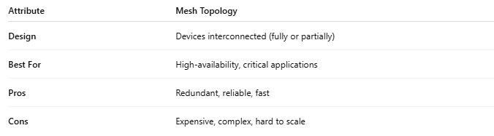
Attribute | Mesh Topology
Design | Devices interconnected (fully or partially)
Best For | High-availability, critical applications
Pros | Redundant, reliable, fast
Cons | Expensive, complex, hard to scale

